Pararhyme

🔹 What is Pararhyme
# Source: AI Source: Provided by: [Data Path: Persons Table -> ID Column: 1, Name_En Column: Motasem Essam] -> From: [Chatgpt (GPT-4-turbo)] on [8/1/2025]
(Pararhyme as a phonetic phenomenon, not semantic homograph)

⚠️ Clarification First:
# Source: AI Source: Provided by: [Data Path: Persons Table -> ID Column: 1, Name_En Column: Motasem Essam] -> From: [Chatgpt (GPT-4-turbo)] on [8/1/2025]
Pararhyme is not a type of homograph in the strict linguistic sense.
It is a type of rhyme—used in poetry and phonology—where consonants are the same, but the vowels differ.
However, some homographs can incidentally form pararhymes when pronounced differently in poetic contexts. This is why there's occasional overlap, especially in sound-based wordplay.

✅ Definition of Pararhyme
# Source: AI Source: Provided by: [Data Path: Persons Table -> ID Column: 1, Name_En Column: Motasem Essam] -> From: [Chatgpt (GPT-4-turbo)] on [8/1/2025]
Pararhyme is a rhyme in which the consonants match at both the beginning and end, but the vowel sounds differ.
Developed and popularized by poet Wilfred Owen.

🔊 Phonetic Pattern:
# Source: AI Source: Provided by: [Data Path: Persons Table -> ID Column: 1, Name_En Column: Motasem Essam] -> From: [Chatgpt (GPT-4-turbo)] on [8/1/2025]
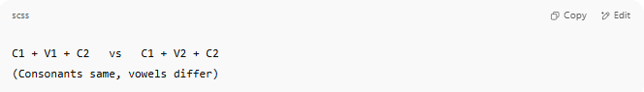
C1 + V1 + C2 vs C1 + V2 + C2
(Consonants same, vowels differ)

📝 Examples of Pararhyme
# Source: AI Source: Provided by: [Data Path: Persons Table -> ID Column: 1, Name_En Column: Motasem Essam] -> From: [Chatgpt (GPT-4-turbo)] on [8/1/2025]
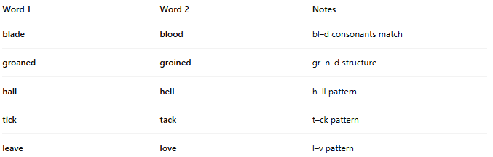
Word 1 | Word 2 | Notes
blade | blood | bl–d consonants match
groaned | groined | gr–n–d structure
hall | hell | h–ll pattern
tick | tack | t–ck pattern
leave | love | l–v pattern

📚 Homographs as Pararhymes?
# Source: AI Source: Provided by: [Data Path: Persons Table -> ID Column: 1, Name_En Column: Motasem Essam] -> From: [Chatgpt (GPT-4-turbo)] on [8/1/2025]

Rarely, a homograph pronounced in two ways may act as a pararhyme pair with itself or with another word. For example:
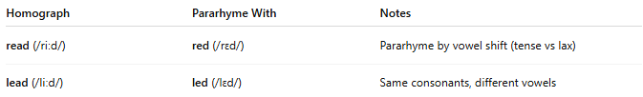
Homograph | Pararhyme With | Notes
read (/riːd/) | red (/rɛd/) | Pararhyme by vowel shift (tense vs lax)
lead (/liːd/) | led (/lɛd/) | Same consonants, different vowels
These examples aren’t pure homographic pararhymes, but show how spelling overlap and pronunciation variation can mimic the effect.

🧭 Summary Table
# Source: AI Source: Provided by: [Data Path: Persons Table -> ID Column: 1, Name_En Column: Motasem Essam] -> From: [Chatgpt (GPT-4-turbo)] on [8/1/2025]
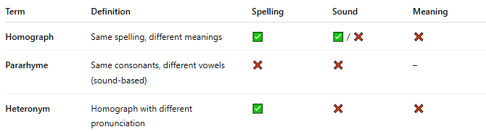
Term | Definition | Spelling | Sound | Meaning
Homograph | Same spelling, different meanings | ✅ | ✅ / ❌ | ❌
Pararhyme | Same consonants, different vowels (sound-based) | ❌ | ❌ | –
Heteronym | Homograph with different pronunciation | ✅ | ❌ | ❌

✅ Conclusion
# Source: AI Source: Provided by: [Data Path: Persons Table -> ID Column: 1, Name_En Column: Motasem Essam] -> From: [Chatgpt (GPT-4-turbo)] on [8/1/2025]
- Pararhyme is a phonological (sound-based) phenomenon, not a true homograph type.
- Some homographs with multiple pronunciations may form pararhymes by coincidence.
- It's best categorized under types of rhyme, not types of homographs.

